Effect of changing parameters

Loss vs Epochs (Basic code): Epochs 500, Optimizer: Adam, Activation: tanh

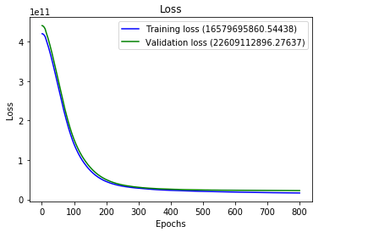

Effect of adding more layer:

* Loss gets better
* Loss decreases faster

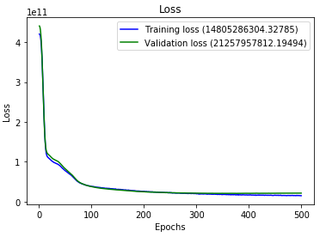

Effect of changing the optimizer:

* With optimizer RMSprop, curve gets worse.

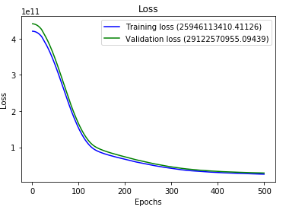

Effect of changing the activation function:

* Using sigmoid activation function, curve gets worse.

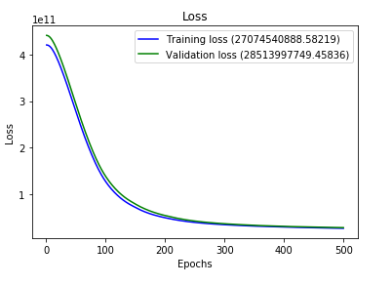

Effect of changing the batch size:

* Simulation gets faster if batch size is increased it gets slower if batch size is decreased.
* Loss gets worse with increased batch size.

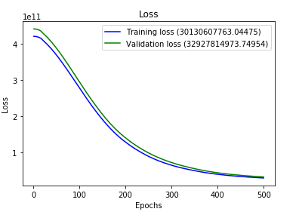

* Loss gets better with decreased batch size.

